



**SMART ANTENNA FOR BRAIN TUMOUR APPLICATIONS**

**A PROJECT REPORT**

***Submitted by***

**BALAJI R 211715106018**

**BALAJI V 211715106019**

**BUVANESH G 211715106022**

***In partial fulfilment for the award of the degree of***

**BACHELOR OF ENGINEERING**

**IN**

**ELECTRONICS AND COMMUNICATION ENGINEERING**

**RAJALAKSHMI INSTITUTE OF TECHNOLOGY**

**CHENNAI**

**ANNA UNIVERSITY: CHENNAI 600 025**

**APRIL 2019**

i

**ANNA UNIVERSITY CHENNAI: CHENNAI 600 025**

**BONAFIDE CERTIFICATE**

Certified that this Report “**SMART ANTENNA FOR BRAIN TUMOR APPLICATION**” is the bonafidework of **Balaji R (211715106018), Balaji V (211715106019)** and **Buvanesh G (211715106022)** who carried out the work under my supervision

**SIGNATURE SIGNATURE**

**Dr. R. RAJESWARI, M.E., Ph.D., S.Kalaivani, M.Tech,**

**HEAD OF THE DEPARTMENT SUPERVISOR**

Professor Professor

Department of Electronics and Department of Electronics and

Communication Engineering Communication Engineering

Rajalakshmi Institute of Technology Rajalakshmi Institute of Technology

Kuthambakkam Post Kuthambakkam Post

Chennai-600124 Chennai-600124

ii

**CERTIFICATE OF EVALUTION**

**College Name : 2117- Rajalakshmi Institute of Technology**

**Branch & Semester : Electronics and Communication Engineering. VIII sem.**

**Subject : EC6811 PROJECT WORK**

**TITLE OF THE PROJECT:**

Smart Antenna for Brain Tumour Application.

**NAME OF THE STUDENT:**

**BALAJI.R 211715106018**

**BALAJI.V 211715106019**

**BUVANESH.G 211715106022**

The report on the project work submitted by the above students in partial fulfilment for the award of the degree of Bachelor of Engineering in ELECTRONICS AND COMMUNICATION ENGINEERING of Anna University, reported the work done by the above students and then evaluated.

**The University Viva-voice was held on________________**

**INTERNAL EXAMINER EXTERNAL EXAMINER**

iii

**ACKNOWLEDGEMENT**

We wish express our hearty and sincere gratitude to our chairman **Dr.S.MEGANATHAN. B.E.,F.I.E,** for his sincere endeavor in educating us in his premier institution.

We wish to express our deep gratitude to our beloved chairperson **Dr.HAREE SHANKAR, MBBS,**for his enthusiastic motivation which helped us a lot in completing the project.

We express our thankfulness to **Dr.M.VELAN, M.E., Ph.D.,**Principal, Rajalakshmi Institute of Technology for their kind support and the facilities provided to complete our work in time.

With profound since and regards, we acknowledge with great pleasure **Dr.R.RAJESWARI.M.E., Ph.D.,** Head of the Department, Department of Electronics and Communication Engineering for his valuable suggestions and guidance for the development and completion of our project.

We express our sincere thanks to our guide **S.KALAIVANI., M.E,.** Professor, Department of Electronics and Communication Engineering, for leading us on the project.

We expend our gratitude to **Mr.K.SIVAKUMAR,M.E.,(Ph.D).,** Assistant Professor(SS), project coordinator for their timely organization of reviews and their support throughout the project work.

We also thanks our review committee members **Dr.R.RAJESWARI,** professor and **Dr.G.NIRMALA PRIYA,** professor, Department of Electronics and Communication Engineering for her valuable suggestions and guidance for the development and completion of our project.

Finally, we express our deep sense of gratitude to our parents, all our faculty members, technical staff and all our friends for their constant encouragement and moral support.

Iv

**ABSTRACT**

In this method of detecting of Brain Tumour using Smart Antenna, a 3D model of the human brain is taken as the input so that the exact shape of the tumour can be identified. This detection in Tumour is very important in many diagnostic and therapeutic applications. Because of high quantity data in MRI images and blurred boundaries, tumour identification, segmentation and classification is very hard. This model proposes an brain tumour detection method to increase the accuracy and decrease the diagnosis time as well as reducing the side effects of radiation. Accurate detection of brain tumour is done by Specific Absorption Rate of the normal cells and tumour cells plays a vital role in the diagnosis of tumour. The diagnosis method consists of three stages, Antenna testing and error calculation, Sam Phantom without tumour, Sam Phantom with tumour.

V

**TABLE OF CONTENT**

**CHAPTER NUMBER TITLE PAGE NO**

**ABSTRACT**

**LIST OF TABLES**

**LIST OF FIGURES**

**LIST OF ABREVATIONS**

1. **INTRODUCTION**
   1. Brain Cancer Statistics
   2. Types of Brain Cancer

1.2.1 Primary Brain Tumour

1.2.2 Secondary Brain Tumour

1. **LITRATURE SURVEY**
   1. Work proposed by various authors
2. **METHODOLOGY**
   1. Block Diagram
   2. Frame Slicing
   3. Pre-Processing

3.3.1 Noise in MRI

3.3.1.1 Salt and Pepper Noise

3.3.2 Median Filter

3.4 DT-CWT Transform

3.5 GLCM Feature Extraction

3.5.1 GLCM features

3.6 Convolutional Neural Network

3.7 Fuzzy C-Means Clustering

3.8

**4 EXPERIMENT RESULTS AND DISCUSSION**

4.1 Prototype

**5 CONCLUSION**

**LIST OF TABLES**

vi

**LIST OF FIGURES**

**1.1** Tumour development stages

**1.2** Brain Cancer Statistics

**1.3** Brain Tumour Images

**3.1** Block Diagram

**3.2** Salt and Pepper Noise

**3.3** Value of wavelet coefficient in “Real-Valued Discrete Wavelet Transform

and Filter Banks”

**3.4** Analysis FB for the DWT with invertible complex post-filtering.

**3.5** q-shift complex wavelet corresponding to a set of orthonormal DT-filter

**3.6** Architecture of CNN

**4.1** Running the code

**4.2** Selecting the input

**4.3(a)** Loading video into the program

**4.3(b)** Loading video into the program

**4.4** Alert Box displaying no Tumour is present

**4.5** Alert Box displaying Tumour is present

**4.6(a)** Segmented Image

**4.6(b)** Segmented Image

vii

**LIST OF ABBREVIATIONS**

**1D** One Dimensions

**2D** Two Dimensions

**RMS** Root Mean Square

**dB** Decibel

**dBi** Decibel Isotropic

**ISM** Industrial Scientific Medical

**MHz** Mega Hertz

**GHz** Giga Hertz

**CST** Computer Stimulation Technology

**SAR** Specific Absorption Rate

**MRI** Magnetic Resonance Imaging.

**FEM** Finite Element Method

**W** Weber

**Kg** Kilogram

**XML** Extensive Mark up Language

**XPS** XML Paper Specification

**PDF** Portable Document Format

viii

**CHAPTER 1**

**INTRODUCTION**

**INTRODUCTION**

Tumour is an abnormal mass of tissue. Tumours can be benign or malignant (cancerous). There are hundreds of different types of tumours. Their names usually reflect the kind of tissue they arise in, and may also tell you something about their shape or how they grow. Diagnosis depends on the type and location of the tumour. Tumour marker tests and imaging may be used; some tumours can be seen (for example, tumours on the exterior of the skin) or felt (palpated with the hands).

A brain tumour occurs when abnormal cells from within the brain. There are two main types of tumours: malignant or non-cancerous tumours and benign tumours.

Cancerous tumour can be divided into primary tumours, which start within the brain and the secondary tumours, which have spread from elsewhere, known as brain metastasis tumours.

All the types of brain tumours may produce symptoms that vary depending on the part of the brain that is affected. These symptoms may include headaches, seizures, problems with vision, vomiting and mental changes. The headache is classically worse in the morning and goes away with vomiting. Other symptoms may include difficulty in walking, speaking or with sensations. As the disease progresses, unconsciousness may occur. Medical images plays a vital role in brain tumour. Early imaging methods invasive and sometimes dangerous, Pneumoencephalography and cerebral angiography have been abandoned in favour of non-invasive, high resolution techniques.

The brain is an important organ that controls thought, memory, emotion, touch, motor skills, vision, respiration, body temperature, hunger, and many other processes that regulate our body. The spinal cord is a large bundle of nerve fibers that extends from the base of the brain to the lower back. It carries messages to and from the brain and the rest of the body.

A brain tumour is a growth of abnormal cells inside the brain. Most brain tumours that children get are called primary brain tumours, meaning that they originated in the brain and did not spread from somewhere else. Tumours might be localized, remaining in one area, or they might be invasive, spreading into nearby tissues. Tumours are also categorized as benign (non-cancerous) or malignant (cancerous). However, it is difficult to call any brain tumour "benign", because all can cause serious problems.

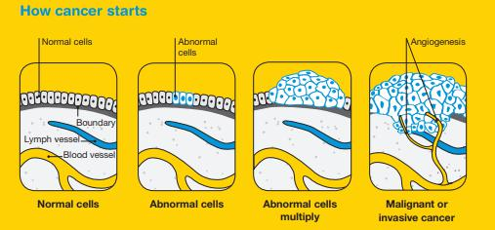

Fig 1.1 Tumour development stages

**1.1 BRAIN CANCER STATISTICS:**

A primary brain or spinal cord tumour is a tumour that starts in the brain or spinal cord. This year, an estimated 23,880 adults (13,720 men and 10,160 women) in the United States was diagnosed with primary cancerous tumours of the brain and spinal cord. Brain tumours account for 85% to 90% of all primary CNS tumours. Also, about 3,560 children will be diagnosed with a brain or CNS tumour this year.

Brain and other nervous system cancer are the 10th leading cause of death for women. It is estimated that 16,830 adults (9,490 men and 7,340 women) will die from primary cancerous brain and CNS tumours this year.

The 5-year survival rate tells you what percent of people lived at least 5 years after the tumour is found. Percent means how many out of 100. The 5-year survival rate for people with cancerous brain or CNS tumours is 34% for men and 36% for women. However, survival rates vary widely and depend on several factors, including the type of brain or spinal cord tumour. Talk with your doctor about what to expect with your diagnosis.

Brain cancer was the 18th most commonly diagnosed cancer in Australia in 2014. It is estimated that it will become the 17th most commonly diagnosed cancer in 2018.

In 2016, there were 1,439 deaths from brain cancer in Australia (878 males and 561 females). In 2018, it is estimated that there will be 1,435 deaths (856 males and 579 females). In 2018, it is estimated that the risk of an individual dying from brain cancer by their 85th birthday will be 1 in 157 (1 in 128 males and 1 in 200 females).

The number of new cases of brain cancer diagnosed increased from 853 (491 males and 362 females) in 1982 to 1,710 in 2014. Over the same period, the age–standardised incidence rate increased from 6.3 cases per 100,000 persons (7.5 for males and 5.1 for females) in 1982 to 6.7 cases per 100,000 in 2014.

The number of deaths from brain cancer increased from 391 (246 males and 145 females) in 1968 to 1,439 in 2016. Over the same period, the age–standardised mortality rate increased from 3.6 deaths per 100,000 persons (4.6 for males and 2.7 for females) in 1968 to 5.3 deaths per 100,000 in 2016.

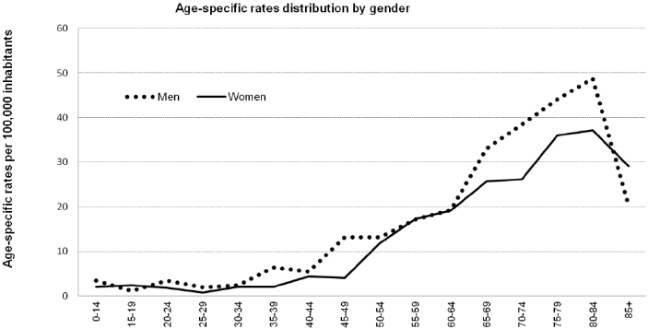

**Figure 1.2 Brain Cancer Statistics**

**Source:** American Society of Clinical Oncology (ASCO).

Link: https://www.cancer.net/cancer-types/brain-tumour/statistics

National Brain Tumour Society

Link: http://blog.braintumour.org/brain-tumour-facts-figures-may-2018-incidence-mortality-and-survival-in-2018/

**1.2 TYPES OF BRAIN TUMOUR**

**Benign tumour:** This kind of tumour is not cancer. It tends to grow slowly.Most benign brain tumours don’t grow into nearby tissue. Once removed, they usually don’t grow back. A benign tumour can cause symptoms like a malignant tumour depending on its size and location in the brain.

**Malignant tumour:** This kind of tumour is cancer. It usually grows fast, and growsinto nearby tissue. This can make it hard to remove fully. A malignant brain tumour may grow back after treatment.

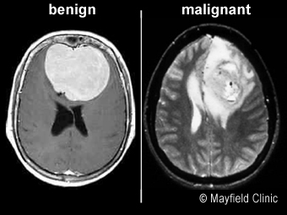

**Figure 1.3 Brain Tumour Images**

Brain tumours can be classified into two general groups:

* Primary brain tumour
* Secondary brain tumour

**1.1.1 PRIMARY BRAIN TUMOUR**

Primary brain tumours are named by the type of brain tissue where they’re found. The most common type of primary brain tumour is a glioma. This type begins in the supportive (glial) tissue of the brain. Some gliomas tend to grow slowly. Others grow and spread quickly.

Some types of glioma include:

**Astrocytoma:** This kind of tumour comes from small star-shaped cells calledastrocytes. In adults, an astrocytoma usually grows in the cerebrum. In children, they can grow in the cerebellum, cerebrum, and brain stem. Most astrocytoma’s spread into nearby normal brain tissue and are hard to cure with surgery. Glioblastoma is a type of astrocytoma that tends to grow very quickly.

5

**Brain stem glioma:** This kind of tumour of the brain stem is more common in

children than in adults. Because the brain stem controls many important functions, such as breathing and heart rate, this kind of tumour usually can’t be removed by surgery.

**Ependymoma:** This kind of tumour starts in cells that line the fluid-filled spaceswithin the brain (ventricles). It doesn’t often grow into nearby brain tissue. This means in some cases it can be cured with surgery.

**Oligodendroglioma:** This kind of tumour starts in cells that make myelin, the fattysubstance that surrounds nerve cells. Like an astrocytoma, this tumour tends to spread into nearby brain tissue and is often hard to cure with surgery.

**Optic nerve glioma:** This kind of tumour grows in or around the nerve that sendsmessages from the eyes to the brain. This can cause vision changes. It can also cause hormone changes, due to its location near the pituitary gland. Other types of primary tumours include:

**Primitive Neuroectodermal Tumour (PNET):** This kind of tumour grows moreoften in children. It can grow anywhere in the brain in the primitive form of nerve cells. One type is the medulloblastoma. This kind of tumour is found in the cerebellum. They are more common in children than in adults. They tend to grow and spread quickly, but they can often be treated effectively.

**Tumour of the pineal gland:** This kind of tumour grows in and around the pinealgland. This is a tiny organ near the centre of the brain. The tumour can be slow-growing, called pineocytoma. Or it can be fast-growing, called pineoblastoma.

**Pituitary tumour:** This kind of tumour starts in the pituitary gland at the base of thebrain. It is almost always benign. But it can cause serious symptoms because of its location, and because it may secrete excess hormones.

**Craniopharyngioma:** This kind of tumour starts near the pituitary gland. It isusually slow growing. But it can cause symptoms if it presses on the pituitary gland or on nearby nerves.

**Schwannoma:** This kind of tumour starts in myelin-making cells that surroundcertain nerves. It’s most common in the vestibular nerve in the inner ear that helps with balance. If it grows there, the tumour is called a vestibular schwannoma or an acoustic neuroma. This type of tumour is usually benign.

**Meningioma:** This kind of tumour starts in the outer linings of the brain (meninges).It is more common in adults. Many meningiomas can be removed with surgery, but some may grow back.

**Primary central nervous system lymphoma:** This is an aggressive, rare type oftumour that starts in lymphocytes. This is a type of immune cell. The tumour is more common in people with a disease of the immune system, such as AIDS. But it can grow in healthy people.

**1.2.2 SECONDARY BRAIN TUMOUR**

A secondary brain tumour is also known as a metastatic brain tumour. This is cancer that starts in another organ and then travels to the brain. In adults, secondary brain tumours are more common than primary brain tumours. Cancer in the brain that has spread from another part of the body is not considered brain cancer. It is still the same type of cancer as where it started. For example, lung cancer that has spread to the brain is called metastatic lung cancer.

These are some of the most common types of cancer that spread to the brain:

* Lung cancer
* Breast cancer
* Melanoma
* Colon cancer
* Kidney cancer

**1.5 ORGANISATION OF THE PROJECT REPORT**

**Chapter 2:** Deals with the previously proposed method and their disadvantages in the methods, and the need to choose a new method.

**Chapter 3:** Details about the microstrip patch antenna for biomedical applications. The simulation results about the patch antenna using Computer Simulation Technology (CST) Software have been discussed. Then about Hardware description also discussed.

**Chapter 4:** Deals with Experiments results and conclusion, we have done both the hardware and software experiments and the results have been successfully verified.

**Chapter 5:** Conclusion of our project have been explained here and future improvement of the project is also well explained.

**CONCLUSION**

Hence the proposed method for detecting brain tumour using Specific Absorption Rate of the microstrip antenna. Here the human brain cells Specific Absorption Rate will be taken as input so that we can identify the tumour cells. This work has introduced one brain tumour detection method to increase the accuracy and yield and decrease the diagnosis time and mainly decrease the side effects caused due to the radiation. The goal is to detect tumour cells from the Brain. The Specific Absorption Rate of human cells and tumour cells are different, this easily helps the identification of tumour. The frequency sent from the patch antenna is absorbed at a high rate by the tumour cells than healthy human cells. By this we can find the presence of tumour cells.

**CHAPTER 2**

**LITERATURE SURVEY**

**INTRODUCTION**

Brain tumour segmentation aims to separate the different tumour tissues such as active cells, necrotic core, and edema from normal brain tissues of White Matter (WM), Gray Matter (GM), and Cerebrospinal Fluid (CSF). MRI-based brain tumour segmentation studies are attracting more and more attention in recent years due to non-invasive imaging and good soft tissue contrast of Magnetic Resonance Imaging (MRI) images. With the development of almost two decades, the innovative approaches applying computer-aided techniques for segmenting brain tumour are becoming more and more mature and coming closer to routine clinical applications.

Nowadays, brain tumour segmentation methods can be organized into different categories based on different principles. In the clinic, brain tumour segmentation methods are usually classified into three main categories including manual, semi-automatic, and fully automatic segmentations based on the degree of required human interaction.

For manual brain tumour segmentation, the experts of brain tumour must master the information presented in the brain tumour images and some additional knowledge such as anatomy because manual brain tumour segmentation aims to manually draw the boundaries of the brain tumour and paint the regions of anatomic structures with different labels. To date, manual segmentation is widely applied to clinical trial. In the clinic, since many of brain tumour images are emerging, the manual segmentation of the different regions of brain tumour will become an error-prone and time-consuming task for the experts and yield poor results in a way. Therefore, more advanced segmentation methods such as semi-automatic and fully automatic segmentation methods are required to address this problem.

For semi-automatic brain tumour segmentation, it mainly consists of the user, interaction, and software computing. In the semi-automatic brain tumour methods, the user needs to input some parameters and is responsible for analyzing the visual information and providing feedback response for the software computing. The software computing is targeted at the realization of brain tumour segmentation algorithms. The interaction is in charge of adjusting segmentation information between the user and the software computing. The semi-automatic brain tumour segmentation methods were divided into three main processes: initialization, feedback response, and evaluation. Although brain tumour semi-automatic segmentation methods can obtain better results than manual segmentation, it also comes into being different results from different experts or the same user at different times. Hence, fully automatic brain tumour segmentation methods were proposed.

For fully automatic brain tumour segmentation, the computer determines the segmentation of brain tumour without any human interaction. In general, a fully automatic segmentation algorithm combines artificial intelligence and prior knowledge. With the development of machine learning algorithms that can simulate the intelligence of humans to learn effectively, the study of fully automatic brain tumour segmentation has become a popular research issue.

The semi-automatic and fully automatic segmentation of tumour brain images are faced with great challenges due to usually exhibiting unclear and irregular boundaries with discontinuities and partial-volume effects for brain tumour images. This paper divides the current MRI-based brain tumour segmentation methods into three major categories: conventional methods, classification and clustering methods, and deformable model methods.

Literature review is an assignment of previous task done by various authors and collection of information or data from research papers published in journals to progress our task. There are lot of literatures published before on the same task. Some papers are taken into consideration from which idea of the project is taken.

**2.1 WORK PROPOSED BY VARIOUS AUTHORS:**

Jin Liu, Min Li, Jianxin Wang , Fangxiang Wu, Tianming Liu, and Yi Pan proposed a paper to provide a comprehensive overview for MRI-based brain tumour segmentation methods. Firstly, a brief introduction to brain tumours and imaging modalities of brain tumours is given. Then, the preprocessing operations and the state of the art methods of MRI-based brain tumour segmentation are introduced. Moreover, the evaluation and validation of the results of MRI-based brain tumour segmentation are discussed. Finally, an objective assessment is presented and future developments and trends are addressed for MRI-based brain tumour segmentation methods.This paper has provided a comprehensive overview of the state of the art MRI-based brain tumour segmentation methods. Many of the current brain tumour segmentation methods operate MRI images due to the non-invasive and good soft tissue contrast of MRI and employ classification and clustering methods by using different features and taking spatial information in a local neighborhood into account. The purpose of these methods is to provide a preliminary judgment on diagnosis, tumour monitoring, and therapy planning for the physician.Although most of brain tumour segmentation algorithms have relatively good results in the field of medical image analysis, there is a certain distance in clinical applications. Due to a lack of interaction between researchers and clinicians, clinicians still rely on manual segmentation for brain tumour in many cases. The existence of many tools aims to do pure research and is hardly useful for clinicians. Therefore, embedding the developed tools into more user-friendly environments will become inevitable in the future. Recently, some standard clinical acquisition protocols focusing on feasibility studies are trying to formulate to improve the clinical applications more quickly. Apart from the evaluation of accuracy and validity for the results of brain tumour segmentation, computation time is also an important criterion. The current standard computation time is in general a few minutes. The real-time segmentation will be hard to achieve, but computation time over a few minutes is unacceptable in clinical routine. Another crucial aspect for brain tumour segmentation methods is robustness. If an automatic segmentation technique fails in some cases, clinicians will lose their trust and not use this technique. Therefore, the robustness is also one of the major assessment criteria for each new method applied in clinical practice. Some current brain tumour segmentation methods provide robust results within a reasonable computation time.

Ayşe Demirhan, Mustafa Törü, İnan Güler proposed a paper titled SEGMENTATION OF TUMOUR AND EDEMA ALONG WITH HEALTHY TISSUES OF BRAIN USING WAVELETS AND NEURAL NETWORKS. The paper states that Robust brain magnetic resonance (MR)segmentation algorithms are critical to analyze tissues and diagnose tumour and edema in a quantitative way. In this study, we present a new tissue segmentation algorithm that segments brain MR images into tumour, edema, white matter (WM), gray matter (GM) and cerebrospinal fluid (CSF). The detection of the healthy tissues is performed simultaneously with the diseased tissues because examining the change caused by the spread of tumour and edema on healthy tissues is very important for treatment planning. We used T1, T2 and FLAIR MR images of 20 subjects suffering from glial tumour. We developed an algorithm for stripping the skull before the segmentation process. The segmentation is performed using self-organizing map (SOM) that is trained with unsupervised learning algorithm and fine-tuned with learning vector quantization (LVQ). Unlike other studies, we developed an algorithm for clustering the SOM instead of using an additional network. Input feature vector is constructed with the features obtained from stationary wavelet transform (SWT) coefficients. The results showed that average Dice similarity indexes are 91% for WM, 87% for GM, 96% for CSF, 61% for tumour, and 77% for edema. In this paper, segmentation of brain MR images into healthy tissues such as GM, WM and CSF along with the diseased tissues; tumour and edema. 20 patients suffering from the glial tumour are used. We registered T1, T2 and FLAIR MR Images into one coordinate system after filtering with anisotropic diffusion filter. We developed an algorithm that combines threshold and morphological operations for stripping the skull that is not our region of interest in this study. Performance comparison of the developed algorithm for skull stripping to the well-known algorithms on IBSR database showed that our algorithm outperforms other methods.We used SWT to decompose images into subbands. We performed spatial filtering methods on these subbands to obtain feature vector that will be used as input to the SOM. Segmentation operation is performed by an unsupervised SOM network. We developed an algorithm, based on the hit histograms of the BMUs of the output neurons for clustering the SOM instead of using an additional NN. Supervised LVQ algorithm is used to calibrate the output neurons of the SOM. We used Dice similarity index, sensitivity and specificity to evaluate the performance of the developed algorithm. We compared the results obtained from the system to the regions manually selected by the Radiology physician. The statistical analysis of the experimental results has indicated that the developed algorithm can segment brain MR images with good accuracy. Our overall procedure can segment white matter, gray matter, cerebrospinal fluid, tumour and edema from MR images and requires 20s for each MR volume. We compared our method with the other state-of-the-art brain MR segmentation methods with BRATS2012 dataset. Our method showed a moderate and comparable performance on this dataset.Our future work will focus on improving the segmentation accuracy of the system by using additional features such as prior knowledge, shape and models.

Anil Singh Parihar proposed a paper on Brain Tumour Segmentation Using Convolution Neural Network. We know that Computer vision is playing important role in thefield of human health care. This role is growing day by day. The application of computer vision techniques in health care has one of the aim to reduce human judgement in diagnosis. Thus, human error in judgement may be reduced. Brain related diagnosis demands at most care and a minute error in judgment may be disastrous. This makes medical imaging very important field. Various imaging methods like CT Scans, X -Ray, and MRI are available but MRI is the most reliable and safe. Even the smallest aberrances in the human body can be identified using imaging techniques. More preferred contrast information about brain tissues is provided by Magnetic Resonance imaging (MRI). Image segmentation is an important problem in medical imaging, which involves separating the tumour and organisms out of the medical data. Machine learning (ML) has gained enormous application with innovation in hardware requirements for computing. Convolutional neural networks (CNN) is one of the most effective techniques in ML. CNN has find applications in almost every field of research. CNN also find effective applications in brain MRI segmentation. In this paper, we present a study on CNN based MRI segmentation. The method of using Convolutional Neural Network (CNN) in MR Images was done. Image Segmentation is an important problem in medical imaging which involves segmenting and organisms from medical data. These methods and results are studied for brain tumour segmentation using CNN, first method involves brain tumour segmentation that tackles the diversity if sites, multiple scanner MRI Images using a method of intensity normalisation which shows that its relevant for good segmentation using MRI. Also it compares the parameters for different grades of tumour classes i.e High grade or Low grade tumours. Second method shows segmentation results obtained from distinct ages and using distinct acquisition protocols. It also compares parameters from certain classes.

Adel Kermi, Khaled Andjouh, Ferhat Zidane proposed in their paper a system that is new fully automated, fast, and accurate brain tumour segmentation method which automaticallydetects and extracts whole tumours from 3D-MRI. The proposed method is based on a hybrid approach that relies on a brain symmetry analysis method and a combining region-based and boundary-based segmentation methods. The segmentation process consists of three main stages. In the first one, image pre-processing is applied to remove any noise, and to extract the brain from the head image. In the second stage, automated tumour detection is performed. It is based essentially on FBB method using brain symmetry. The obtained result constitutes the automatic initialisation of a deformable model, thus removing the need of selecting the initial region of interest by the user. Finally, the third stage focuses on the application of region growing combined with 3D deformable model based on geodesic level-set to detect the tumour boundaries containing the initial region, computed previously, regardless of its shape and size. The proposed segmentation system has been tested and evaluated on 3D-MRIs of 285 subjects with different tumour types and shapes obtained from BraTS'2017 dataset. The obtained results turn out to be promising and objective as well as close to ground truth data. In this paper, a fully automated, fast, and accurate method to segment tumour in the brain MRI volume is presented. The method is essentially based on the symmetry analysis of human brain, using the FBB technique to locate the tumour at first, followed by region growing and geodesic level set methods to acquire the final tumour. The FBB algorithm is efficient and completely unsupervised (i.e. does not need any user interaction or training images) and does not necessitate any training phase. It is also very fast (i.e. it can be implemented in real time). In addition, it avoids the challenge of dealing with the variation of intensities among different MRI slices. All those reasons motivated the choice of this algorithm.The proposed method was tested and evaluated on 285 3D-MRI acquired in T2 and FLAIR modality from BraTS 2017 dataset. The average computation time of detecting and segmenting tumour for each case, including the skull-stripping operation from 3D head MRI, is about 5 min, using a standard PC 2 GHz Intel Core 2 Duo with 3GB RAM. The tests showed that the localisation and segmentation results were satisfactory, although the method can be further improved. It is evident that the chances of survival of a tumour-infected patient can be increased significantly if the tumour is detected accurately in its early stage (i.e. very low tumour size). In this study, the smallest tumour correctly segmented by our method has a volume of about 7 cm. Brain MRI volumes with very low tumour size have not been tested due to the no-availability in abundance of such images. It would be, then, important and interesting in future works to perform other tests on 3D-MRI images with very low tumour size as soon as we get them in order to show the relationship between the segmentation performance of our method and the tumour size.Other future works will focus on developing robust segmentation methods for more challenging cases where multiple tumours and diffused boundaries are present in the same image. Also, other interesting perspective consists in developing segmentation method of brain tumour and its components such as necrosis and oedema.

**CONCLUSION:**

Hence the proposed method for detecting brain tumour is by using convolutional neural networks. As of now, Computer vision is playing important role in thefield of human health care. This role is growing day by day. The application of computer vision techniques in health care has one of the aims to reduce human judgement in diagnosis. Thus, human error in judgement may be reduced. Brain related diagnosis demands at most care and a minute error in judgment may be disastrous. This makes medical imaging very important field. Various imaging methods like CT Scans, X -Ray, and MRI are available but MRI is the most reliable and safe. Even the smallest aberrances in the human body can be identified using imaging techniques. More preferred contrast information about brain tissues is provided by Magnetic Resonance imaging (MRI). Image segmentation is an important problem in medical imaging, which involves separating the tumour and organisms out of the medical data. Machine learning (ML) has gained enormous application with innovation in hardware requirements for computing. Convolutional neural networks (CNN) is one of the most effective techniques in ML. CNN has find applications in almost every field of research. CNN also find effective applications in brain MRI segmentation. Since the datasets used here are large, using Support Vector Machines(SVM) won’t be as viable and accurate in determining the required output. Therefore, Neural Networks where in which Convolutional Neural Networks are employed to use such large datasets and perform better compared to Support Vector Machines.

**CHAPTER 3**

**PROPOSED METHODOLOGY**

**INTRODUCTION**

In the proposed model, a 3-D MRI scan is taken as the input to identify the exact shape of the tumour. The diagnosis method consists of four stages: pre-processing of MR images, feature extraction, and classification. After histogram equalization of image, the features are extracted based on Dual-Tree Complex wavelet transformation (DTCWT). In the last stage, Convolutional Neural Network (CNN) is employed to classify the Normal and abnormal brain. Segmentation is done by using Fuzzy C-Means Clustering.

**3.1 BLOCK DIAGRAM:**

3D MRI Scan

3D Frame Slicing

GLCM Feature Extraction

E

Pre-Processing

Normal

Abnormal

Image

Database Images

DT-CWT

Validation

FCM

CNN classifier

Feature Extraction

Cluster the Tumour part

**3.2 FRAME SLICING:**

A slice is a spatially distinct region of a frame that is encoded separately from any other region in the same frame. Frame slicing is a process of converting a video into images by taking frames required at that time. The frames contained in a video clip can be thought of as a volume obtained by considering all the frames in time. This volume can be decomposed into a set of two 2-D temporal slices I(x,t)and I(y,t).

**3.3 PRE-PROCESSING:**

Image Pre-processing is a common name for operations with images at the lowest level of abstraction. Its input and output are intensity images. The aim of pre-processing is an improvement of the image data that suppresses unwanted distortions or enhances some image features important for further processing.

Image restoration is the operation of taking a corrupted/noisy image and estimating the clean original image. Corruption may come in many forms such as motion blur, noise, and camera misfocus. Image restoration is different from image enhancement in that the latter is designed to emphasize features of the image that make the image more pleasing to the observer, but not necessarily to produce realistic data from a scientific point of view. Image enhancement techniques (like contrast stretching or de-blurring by a nearest neighbour procedure) provided by "Imaging packages" use no a priori model of the process that created the image. With image enhancement noise can be effectively be removed by sacrificing some resolution, but this is not acceptable in many applications. In a Fluorescence Microscope resolution in the z-direction is bad as it is. More advanced image processing techniques must be applied to recover the object. De-Convolution is an example of image restoration method. It is capable of: Increasing resolution, especially in the axial direction removing noise increasing contrast.

**3.3.1 NOISE IN MRI:**

Generally MRI images contain a significant amount of noise caused by operator performance, equipment and the environment, which leads to serious inaccuracies MRI seems to be efficient in providing information regarding the location of tumours and even the volume. The noise present in the MRI image can be removed by de-noising techniques whichever is best suited depending upon the image required and then can be processed by any segmentation methods. The noise in MRI image maybe due to field strength, RF pulses , RF coil , voxel volume or receiver bandwidth. Out of which the most prevalent noise is the salt and pepper noise.

**3.3.1.1 SALT AND PEPPER NOISE:**

Salt and Pepper is a form of noise sometimes seen on images. This is also called impulse noise. This noise can be caused by sharp and sudden disturbances in the image signal. It represents itself as sparsely occurring black and white pixels. In another words ( in the sense of pixels), salt and pepper noise means that are high frequencies, so for salt noise the values of this noise type is high (255..200) and for the pepper noise the values of this noise type is low (5..0). An effective noise reduction is a form of noise sometimes seen on images.

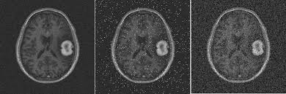

**Figure: 3.2 Salt and Pepper Noise**

**3.3.2 MEDIAN FILTER:**

The median of a distribution is the value for which larger and smaller values are equally probable. To calculate the median of a list of sample values, sort them in any order, and then peek the central value, or the mean between the two central values if the list is even-sized. If your list of values has a strong central tendency, which manifests itself as a single, well defined peak on the histogram, then the median is a good estimator of the peak position. If the distribution has no central peak, or if it is bimodal (two peaks), then the median is mostly meaningless.

Applied to images, median calculation leads to a useful morphological filter. First define a neighborhood for each pixel in the image. This can be as simple as taking a square box centered on each pixel, or can be somewhat more complex. Anyway, each pixel will have its own associated neighborhood, which will consist on a given number of surrounding source pixels. Now calculate the median of each neighborhood and store all of them in a safe place. Finally, replace each pixel with the median value of its associated neighborhood.

Among other applications, a median filter can be a useful tool for noise reduction. Why? There is a type of noise, known as impulsional noise, that is characterized by bright and/or dark high-frequency (small in relative scale) features appearing randomly over the image. Statistically, impulsional noise falls well outside the peak of the distribution of any given pixel neighborhood, so the median is well suited to learn where impulsional noise is not present, and hence to remove it by exclusion.

Stellar objects can be interpreted as a sort of impulsional noise in deep-sky images, especially when they are numerous: they are more or less randomly distributed, they are bright, and they are small. Taking advantage of this fact, the median filter can be used to remove or isolate stars on deep-sky astro-photos, usually with the purpose of building masks. The median filter is an effective method that can, to some extent, distinguish out-of-range isolated noise from legitmate image features such as edges and lines. Specifically, the median filter replaces a pixel by the median, instead of the average, of all pixels in a neighborhood **w,**

**y[m,n]=median{x[i,j],(i,j) ɛ w}**

Where, **w** represents a neighborhood defined by the user, centered around location **[m,n]** in the image.

**1D median filter:** Consider a 1x5 window sliding over a 1D array (either horizontal or vertical) of pixels. Assume the five pixels currently inside the windows are:

\framebox[0.5in]{80} \framebox[0.5in]{90} \framebox[0.5in]{200} \framebox[0.5in]{110} \framebox[0.5in]{120}

where the middle pixel with value 200 is an isolated out-of-range and is therefore likely to be noisy. The median of these five values can be found by sorting the values (in either ascending or descending order). The median is 110, the value in the middle:

\framebox[0.5in]{80} \framebox[0.5in]{90} \framebox[0.5in]{110} \framebox[0.5in]{120} \framebox[0.5in]{200}

The original pixel value 200 is replaced by the median 110.

**2D median filter:** The window of a 2D median filter can be of any central symmetric shape, a round disc, a square, a rectangle, or a cross. The pixel at the centre will be replaced by the median of all pixel values inside the window.

**3.4 DUAL-TREE COMPLEX WAVELET TRANSFORMS (DT-CWT):**

The dual-tree complex wavelet transform (CWT) is a relatively recent enhancement to the discrete wavelet transform (DWT), with important additional properties: It is nearly shift invariant and directionally selective in two and higher dimensions. It achieves this with a redundancy factor of only 2*d* for *d*-dimensional signals, which is substantially lower than the undecimated DWT. The multidimensional (M-D) dual-tree CWT is no separable but is based on a computationally efficient, separable filter bank (FB). The theory behind the dual-tree transforms shows how complex wavelets with good properties can be designed, and illustrates a range of applications in signal and image processing.



**Figure: 3.3 the value of the wavelet coefficient in “Real-Valued Discrete Wavelet Transform and Filter Banks**

In the neighbourhood of an edge, the real DWT produces both large and small wavelet coefficients. In contrast, the (approximately) analytic CWT produces coefficients whose magnitudes are more directly related to their proximity to the edge. Here, the test signal is a step edge at *n* = *no*,*x(n)* = *u(n* − *no)*. The figure shows the value of the wavelet coefficient *d(*0*,* 8*)* (the eighth coefficient at stage 3 in “Real-Valued Discrete Wavelet Transform and Filter Banks, as a function of *no*. In the top panel, the real coefficient *d(*0*,* 8*)* is computed using the conventional real DWT. In the lower panel, the complex coefficient*(*0*,* 8*)* is computed using the dual-tree CWT.

**Wavelet transform and Multi-scale analysis:**

The wavelet transform has been exploited with great success across the gamut of signal processing applications, in the process, often redefining the state of the art performance. In a nutshell, the DWT replaces the infinitely oscillating sinusoidal basis functions of the Fourier transform with a set of locally oscillating basis functions called *wavelets*. In the classical setting, the wavelets are stretched and shifted versions of a fundamental, real-valued band pass wavelet *ψ(t )*. When carefully chosen and combined with shifts of a real-valued low-pass scaling function *φ(t )*, they form an orthonormal basis expansion for one-dimensional (1-D) real-valued continuous-time signals. That is, any finite energy analog signal *x(t )* can be decomposed in terms of wavelets and scaling functions via

The scaling coefficients *c(n)* and wavelet coefficients *d( j, n)* are computed via the inner products,

They provide a time-frequency analysis of the signal by measuring its frequency content (controlled by the scale factor *j*) at different times (controlled by the time shift *n*).There exists a very efficient, linear time complexity algorithm to compute the coefficients *c(n)* and *d( j, n)* from a fine-scale representation of the signal (often simply *N* samples) and vice versa based on two octave-band, discrete-time FBs that recursively apply a discrete-time low-pass filter *h*0*(n)*, a high-pass filter*h*1*(n)*, and up sampling and down sampling operations. These filters provide a convenient parameterization for designing wavelets and scaling functions with desirable properties, such as compact time support and fast frequency decay (to ensure the analysis is as local as possible in time frequency) and orthogonality to low-order polynomials (vanishing moments). This corresponds to a rotation of both filters in the *z*-plane by 90°. If *h*0*(n)* and *h*1*(n)* satisfy the PR conditions, then so will *h*p*(n)* and *h*n*(n)*. The given low-pass/high-pass filters*h*0*(n)*, *h*1*(n)* illustrated in the frequency domain, the complex filters *h*p*(n)*, *h*n*(n)* are illustrated in the frequency domain in Figure 4. When used by itself, this complex can effectively separate the positive and negative frequency components of a signal; in a discrete-time sense, *h*p*(n)* and *h*n*(n)* are approximately analytic.



**Fig:3.4 Analysis FB for the DWT with invertible complex post-filtering.**

**Shift Variance:**

A small shift of the signal greatly perturbs the wavelet coefficient oscillation pattern around singularities. Shift variance also complicates wavelet-domain processing; algorithms must be made capable of coping with the wide range of possible wavelet coefficient patterns caused by shifted singularities



**Fig: 3.5 A q-shift complex wavelet corresponding to a set of orthonormal dual-tree filters of length**

To better understand wavelet coefficient oscillations and shift variance, consider a piecewise smooth signal *x(t*−*t*0*)* like the step function

Analyzed by a wavelet having a sufficient number of vanishing moments. Its wavelet coefficients consist of samples of the step response of the wavelet

Where, is the height of the jump: Since *ψ(t )* is a band pass function that oscillates around zero, so does its step response *d( j, n)* as a function of *n* (recall Figure 1). Moreover, the factor2 *j* in the upper limit ( *j*≥ 0) amplifies the sensitivity of *d( j, n)*to the time shift *t*0, leading to strong shift variance.

**Complex Wavelets:**

The key is to note that the Fourier transform does not suffer from these problems. First, the magnitude of the Fourier transform does not oscillate positive and negative but rather provides a smooth positive envelope in the Fourier domain. Second, the magnitude of the Fourier transform is perfectly shifting invariant, with a simple linear phase offset encoding the shift. Third, the Fourier coefficients are not aliased and do not rely on a complicated aliasing cancellation property to reconstruct the signal and fourth, the sinusoids of the M-D Fourier basis are highly directional plane waves. The DWT, which is based on real-valued oscillating wavelets, the Fourier transform is based on complex-valued oscillating sinusoids

The oscillating cosine and sine components (the real and imaginary parts, respectively) form a Hilbert transform pair; i.e., they are 90◦ out of phase with each other. Together they constitute an analytic signal *e* j*_t* that is supported on only one-half of the frequency axis (*_ >*0).The oscillating cosine and sine components (the real and imaginary parts, respectively) form a Hilbert transform pair; i.e., they are 90◦ out of phase with each other. Together they constitute an analytic signal *e* j*_t* that is supported on only one-half of the frequency axis (*_ >*0).

**3.5 GREY LEVEL- CO-OCCURANCE MATRIX (GLCM):**

A Co-occurrence matrix (CCM) by calculating how often a pixel with the intensity (gray-level) value i occurs in a specific spatial relationship to a pixel with the value j. By default, the spatial relationship is defined as the pixel of interest and the pixel to its immediate right (horizontally adjacent), but you can specify other spatial relationships between the two pixels.Each element (i,j) in the resultant ccm is simply the sum of the number of times that the pixel with value i occurred in the specified spatial relationship to a pixel with value j in the input image. The number of gray levels in the image determines the size of the CCM. It is of 2nd order statistics, so information with regards to pixels of pairs are collected by GLCM.GLCM exhibits how the pixel brightness in an image occurs..A matrix is built up at a distance d=1 and at angles in degrees(0,45,90,135) .Haralick also offered different measures i.e. entropy, energy, contrast, correlation etc. These dimensions calculate at different angles.

After you create the GLCMs, using [graycomatrix,](https://in.mathworks.com/help/images/ref/graycomatrix.html) you can derive several statistics from them using [graycoprops.](https://in.mathworks.com/help/images/ref/graycoprops.html) Medical images have a large number of features and it is important to extract and use the required and essential number of features for minimizing the complexity of processing. In domain of image processing feature extraction is performed on the images for retrieving the values i.e., (features) that prove to be informative, non-redundant and help in the learning and knowledge gathering about the given images for carrying out better human understanding and interpretations. Feature extraction can also be called as Dimensionality Reduction. This process of feature extraction is carried out using Grey Level CO-Occurrence Matrix (GLCM).

The tumour caused due to multiplication of cancer causing cells in the lung is the feature extracted in the implemented system. Grey Level CO-Occurrence Matrix (GLCM) is used for this process of feature extraction in the implemented system. Feature Extraction is a method of capturing visual content of images for indexing & retrieval. When low level images , the features can be in the form general features, such as color extraction, texture and shapes.

Computing the texture features from the distribution of combination of intensities by testing the positions comparative to each other in the image is made in quality analysis,. According to the number of concentration points (pixels) in each grouping, statistics are classify into first-order, second order and higher-order statistics. The Gray Level Co-occurrence Matrix (GLCM) technique is a way of extract second order statistical quality features. The approach has been used in a number of applications, Third and higher order textures consider the relationships among three or more pixels.

GLCM is texture character profile and this profile mention to touch i.e. smooth, silky and rough etc. The order of character profile statics are:

**First order texture** measures are statistics declared from the original image values, like variance, and pixel neighbour relationship are not implemented.

**Second order texture** defines the relationship between groups of two (usually neighbouring) pixels in the original image.

**Third and higher order textures** (noting the relationships among three or more pixels) are theoretically possible but practically/ commonly not implemented due to calculation time and interpretation difficulty.

GLCM texture picks up the relation between two pixels at a time, called the reference and the neighbour pixel. GLCM expounds the distance and angular spatial relationship over an image sub- region of specific size. GLCM is prepared from gray scale values. It is taken into account how often a pixel with gray level (gray scale intensity or gray tone) values come either horizontally, vertically and diagonally to levelled

**GLCM Properties:**

The properties of GLCM are:

1. GLCM is of square in shape because the reference and neighbouring pixels have same range of values.
2. Number of rows and columns equal to the quantization level of the image.

3. It is symmetrical about the diagonal.

**3.5.1 GLCM FEATURES:**

The features extracted are:

* **Energy:** It is a measure the homogeneousness of the image and can be calculated from the normalized COM. It is a suitable measure for detection of disorder in texture image. Since energy is used for doing work, Thus orderliness. It makes use for the texture that calculates orders in an image. It gives the sum of square elements in GLCM. It is fully different from entropy. When the window is proficient orderly, energy value is high .The square root of ASM (Angular Second Moment) texture character is used as Energy. Its range is[0 1].Since constant image its value is 1.The equation of energy is
* **Entropy:** Entropy gives a measure of complexity of the image. Complex textures tend to have higher entropy

**Where,**

p(i , j) is the co occurrence matrix

* **Contrast :** Measures the local variations and texture of shadow depth in the gray level co-occurrence matrix. In short form, it is called CON. ’Sum of Square Variance’ is another name of Contrast. It defers the calculation of the intensity contrast linking pixel and its neighbour over the whole image.

* **Correlation:** Measures the joint probability occurrence of the specified pixel pairs. It passes the calculation of the correlation of the pixel and its neighbor over the whole image means it figured out the linear dependency of grey levels on those of neighboring pixels. On behalf of a perfectly positive or negative correlated image, the correlation value is 1 and -1. On behalf of a constant image its value is NaN. Range[1,-1] and the formula is:
* **Homogeneity:** Measures the closeness of the distribution of elements in the GLCM to the GLCM diagonal. In short term it is going by the name of HOM. It passes the value that calculates the tightness of distribution of the elements in the GLCM to the GLCM diagonal. For diagonal GLCM its value is 1 and its range is [0,1].Opposite of contrast weight is homogeneity weight values, with weight decreases exponentially loose from the diagonal. The weight employed in contrast is (i-j)^2 and in homogeneity ,it is 1/1+(i-j)^2.The equation is

**3.6 CONVOLUTIONAL NEURAL NETWORK (CNN):**

In deep learning, a convolutional neural network (CNN, or ConvNet) is a class of deep neural networks, most commonly applied to analyzing visual imagery. CNNs use a variation of multilayer perceptrons designed to require minimal preprocessing they are also known as shift invariant or space invariant artificial neural networks (SIANN), based on their shared-weights architecture and translation invariance characteristics.

Convolutional networks were inspired by biological processes in that the connectivity pattern between neurons resembles the organization of the animal visual cortex. Individual cortical neurons respond to stimuli only in a restricted region of the visual field known as the receptive field. The receptive fields of different neurons partially overlap such that they cover the entire visual field.CNNs use relatively little pre-processing compared to other image classification algorithms. This means that the network learns the filters that in traditional algorithms were hand-engineered. This independence from prior knowledge and human effort in feature design is a major advantage.

They have applications in image and video recognition, recommender systems, image classification, medical image analysis, and natural language processing

**ARCHITECTURE OF CNN:**

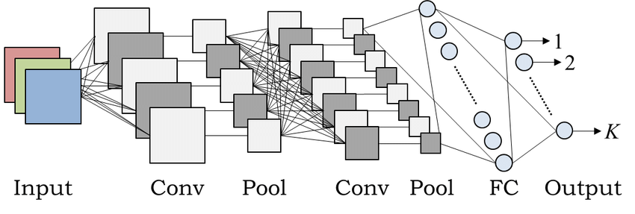

**Figure 3.6: Architecture of CNN**

**DESIGN:**

A convolutional neural network consists of an input and an output layer, as well as multiple hidden layers. The hidden layers of a CNN typically consist of convolutional layers, RELU layer i.e. activation function, pooling layers, fully connected layers and normalization layers. Description of the process as a convolution in neural networks is by convention. Mathematically it is a cross-correlation rather than a convolution (although cross-correlation is a related operation). This only has significance for the indices in the matrix, and thus which weights are placed at which index.

**CONVOLUTIONAL:**

Convolutional layers apply a convolution operation to the input, passing the result to the next layer. The convolution emulates the response of an individual neuron to visual stimuli. Each convolutional neuron processes data only for its receptive field. Although fully connected feedforward neural networks can be used to learn features as well as classify data, it is not practical to apply this architecture to images. A very high number of neurons would be necessary, even in shallow (opposite of deep) architecture, due to the very large input sizes associated with images, where each pixel is a relevant variable. For instance, a fully connected layer for a (small) image of size 100 x 100 has 10000 weights for *each* neuron in the second layer. The convolution operation brings a solution to this problem as it reduces the number of free parameters, allowing the network to be deeper with fewer parameters. For instance, regardless of image size, tiling regions of size 5 x 5, each with the same shared weights, requires only 25 learnable parameters. In this way, it resolves the vanishing or exploding gradients problem in training traditional multi-layer neural networks with many layers by using back propagation.

**POOLING:**

Convolutional networks may include local or global pooling layers which combine the outputs of neuron clusters at one layer into a single neuron in the next layer. For example, max pooling uses the maximum value from each of a cluster of neurons at the prior layer. Another example is average pooling, which uses the average value from each of a cluster of neurons at the prior layer.

**FULLY CONNECTED:**

Fully connected layers connect every neuron in one layer to every neuron in another layer. It is in principle the same as the traditional multi-layer perceptron neural network (MLP).

**RECEPTIVE FIELD:**

In neural networks, each neuron receives input from some number of locations in the previous layer. In a fully connected layer, each neuron receives input from every element of the previous layer. In a convolutional layer, neurons receive input from only a restricted subarea of the previous layer. Typically the subarea is of a square shape (e.g., size 5 by 5). The input area of a neuron is called its receptive field. So, in a fully connected layer, the receptive field is the entire previous layer. In a convolutional layer, the receptive area is smaller than the entire previous layer.

**WEIGHTS:**

Each neuron in a neural network computes an output value by applying some function to the input values coming from the receptive field in the previous layer. The function that is applied to the input values is specified by a vector of weights and a bias (typically real numbers). Learning in a neural network progresses by making incremental adjustments to the biases and weights. The vector of weights and the bias are called a filter and represents some feature of the input (e.g., a particular shape). A distinguishing feature of CNNs is that many neurons share the same filter. This reduces memory footprint because a single bias and a single vector of weights is used across all receptive fields sharing that filter, rather than each receptive field having its own bias and vector of weights.

**3.7 FUZZY C-MEANS CLUSTERING ALGORITHM:**

The fuzzy c-means clustering algorithm partitions data points into k clusters Sl (l = 1, 2, …, k) and clusters Sl are associated with representatives (cluster centre) Cl. The relationship between a data point and cluster representative is fuzzy. That is, a membership ∈ [0, 1] is used to represent the degree of belongingness of data point Xi and cluster centre. Denote the set of data points as S = {Xi}. The FCM algorithm is based on minimizing the following distortion:

with respect to the cluster representatives and memberships , where N is the number of data points; m is the fuzzier parameter; k is the number of clusters; and is the squared Euclidean distance between data point Xi and cluster representative . It is noted that should satisfy the following constraint:

The major process of FCM is mapping a given set of representative vectors into an improved one through partitioning data points. It begins with a set of initial cluster centres and repeats this mapping process until a stopping criterion is satisfied. It is supposed that no two clusters have the same cluster representative. In the case that two cluster centres coincide, a cluster centre should be perturbed to avoid coincidence in the iterative process. If d(I,j)< η, then ui,j = 1 and ui,l = 0 for l ≠ j, where η is a very small positive number. The fuzzy c-means clustering algorithm is now presented as follows.

Denote the subsets, which consist of active cluster centres and stable cluster centres as and SCs, respectively. Let be the number of clusters in at the iteration of fuzzy c-means clustering. The value of decreases as the iteration proceeds in general. The performance, in terms of computing time, of the proposed method is better, if decreases more quickly during the process of iteration. The value and creasing rate of depend on data distribution. For a data set with good data separation, will decrease quickly. For an evenly distributed data set, will decrease slowly. For a real data set, a good data separation is usually obtained. In the worst case, equals k, which is the number of clusters. It is noted that centres of clusters in the previous iteration will be used to partition the set of data points {Xi} in the current iteration. The FCM algorithm stops, if the displacements of all cluster centres are less than ε. That is, if Dj< ε, then cluster Sj is a stable cluster and dij (i = 1 to N) will not be recalculated to update in the iterative process. The proposed algorithm will use this property to speed up fuzzy k-means clustering. Now, the fuzzy c-means clustering algorithm using cluster displacement (CDFCM) is presented below.

**Segmentation:**

After the development of the decision tree, 8 postal images were segmented using the front end provided by the decision tree and the back end provided by context-based classification. Execution time is an important consideration for segmentation algorithms, especially for postal systems. The first pass classification based on the six-dimensional feature space runs much faster than the wavelet-based classification. Image segmentation is an image processing technique to separate mutually exclusive homogeneous regions of interest of an image. Segmenting objects in an image plays a fundamental role in the field of image processing and image analysis. Segmenting objects in an image is a very difficult and challenging task due to huge number of objects and the variations among the objects in terms of colour, intensity and locations [1]. Those algorithms and techniques can roughly be categorized into two categories: (i) Boundary-based methods and (ii) Region-based methods. In boundary based methods, an object is segmented by utilizing the discontinuity of pixel intensity in an image and tends to partition an image by detecting isolated points, lines and edges according to abrupt changes. Region-based methods include the techniques of clustering, region growing, and regions splitting and merging. These algorithms exploit the homogeneity of spatially dense information such as intensity, colour, texture etc. Boundary based algorithms are not efficient due to following reasons: (i) these algorithms do not exploit spatial information,

**Texture Features:**

An image texture is a set of metrics calculated in image processing designed to quantify the perceived texture of an image. Image texture gives us information about the spatial arrangement of colour or intensities in an image or selected region of an image. Image textures can be artificially created or found in natural scenes captured in an image. Image textures are one way that can be used to help in [segmentation](https://en.wikipedia.org/wiki/Segmentation_(image_processing)) or classification of images. For more accurate segmentation the most useful features are spatial frequency and an average grey level. To analyze an image texture in computer graphics, there are two ways to approach the issue: Structured Approach and Statistical Approach. A statistical approach sees an image texture as a quantitative measure of the arrangement of intensities in a region. In general this approach is easier to compute and is more widely used, since natural textures are made of patterns of irregular sub elements.

**Edge Detection**

The use of edge detection is to determine the number of edge pixels in a specified region, helps determine a characteristic of texture complexity. After edges have been found the direction of the edges can also be applied as a characteristic of texture and can be useful in determining patterns in the texture. These directions can be represented as an average or in a histogram.

### Co-occurrence Matrices

The co-occurrence matrix captures numerical features of a texture using spatial relations of similar gray tones. Numerical features computed from the co-occurrence matrix can be used to represent, compare, and classify textures. The following are a subset of standard features derivable from a normalized co-occurrence matrix:

One negative aspect of the co-occurrence matrix is that the extracted features do not necessarily correspond to visual perception.

**PERFORMANCE ANALYSIS:**

Three types of noises (Gaussian, Speckle and Salt & pepper noise) are added to the input image and then MSE and PSNR value are calculated as following:

Where,

***h*** symbolizes the matrix data of our original image

***g*** symbolizes the matrix data of our degraded image inquestion

***p*** symbolizes row number of intensity values of theimages and i symbolizes the index of that row

***q*** symbolizes column number of intensity values of theimages and j symbolizes the index of that column

is the maximum signal value that exists in ouroriginal “known to be good” image

**CONCLUSION:**

Thus the proposed system to detect and segment brain tumour using Convolutional Neural Network (CNN) is done. The results are compared to the previous models to determine the accuracy of tumour detection. Thus by using a 3D scan of the MR Image we are able to identify the exact shape of the tumour and by using a Convolutional Neural Network (CNN) we can determine the presence of tumour and Fuzzy C-Means Clustering method is applied to view the segmented image of the tumour.

**CHAPTER 4**

**EXPERIMENTAL RESULTS AND DISCUSSION**

**INTRODUCTION**

In this chapter, description of the results obtained through the proposed model. The working of the model is detailed in this chapter. MATLAB is the software used to implement the proposed model. The diagnosis method consists of four stages, pre-processing of MR images, feature extraction, and classification.

**4.1 PROTOTYPE**

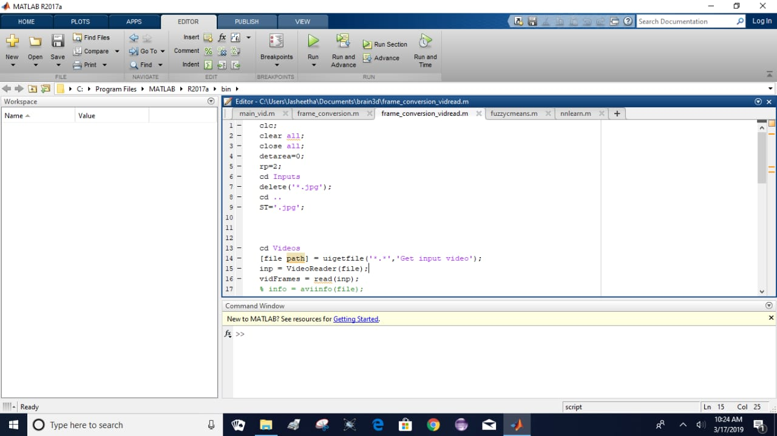

**Figure 4.1 Running the code.**

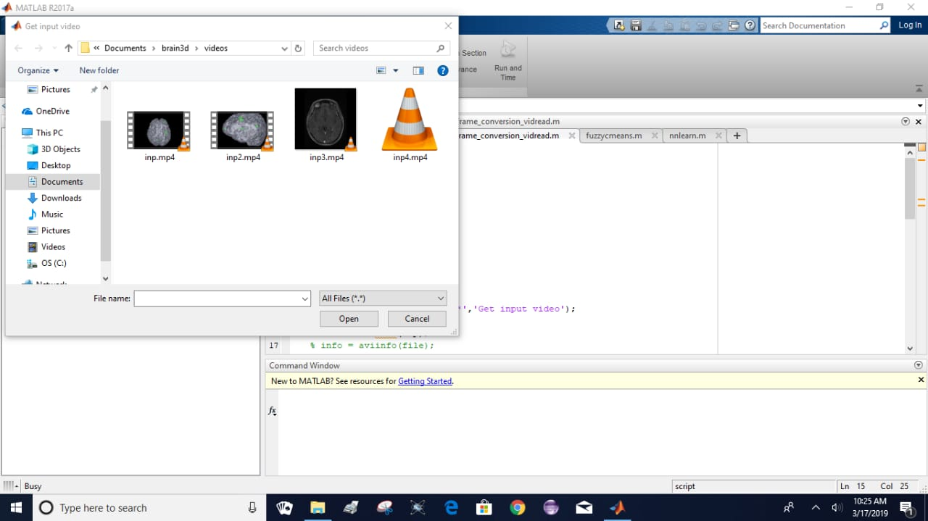

**Figure 4.2 Selecting the input.**

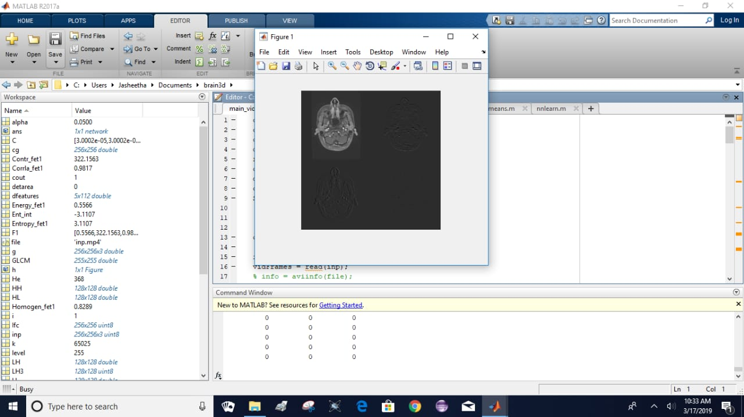

**Figure 4.3(a) Loading the video into the program.**

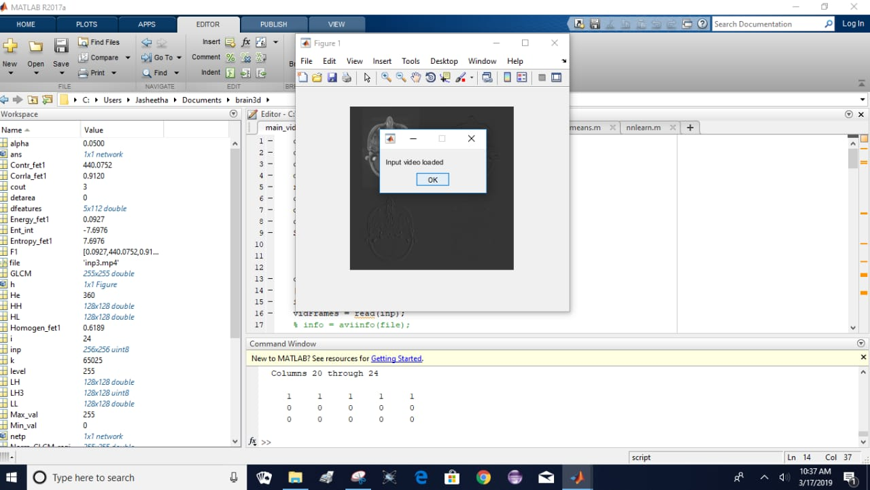

**Figure 4.3(b) Loading the video into the program.**

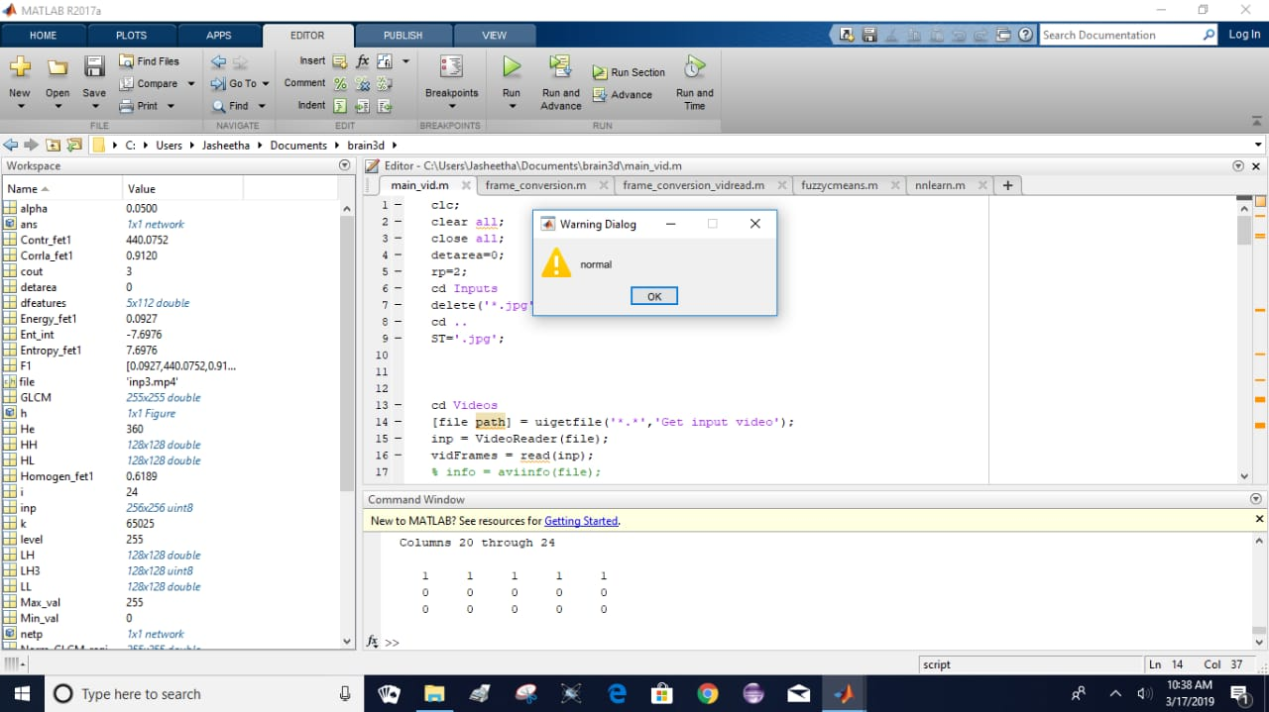

**Figure 4.4 Alert box displaying no tumour is present.**

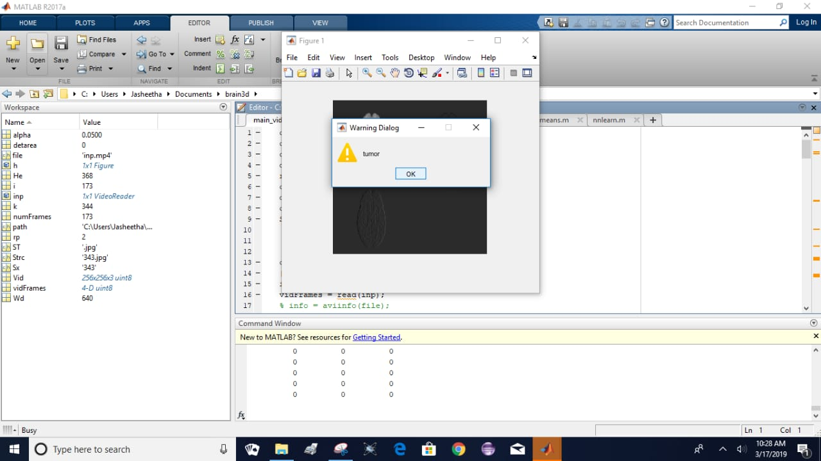

**Figure 4.5 Alert box displaying tumour is present.**

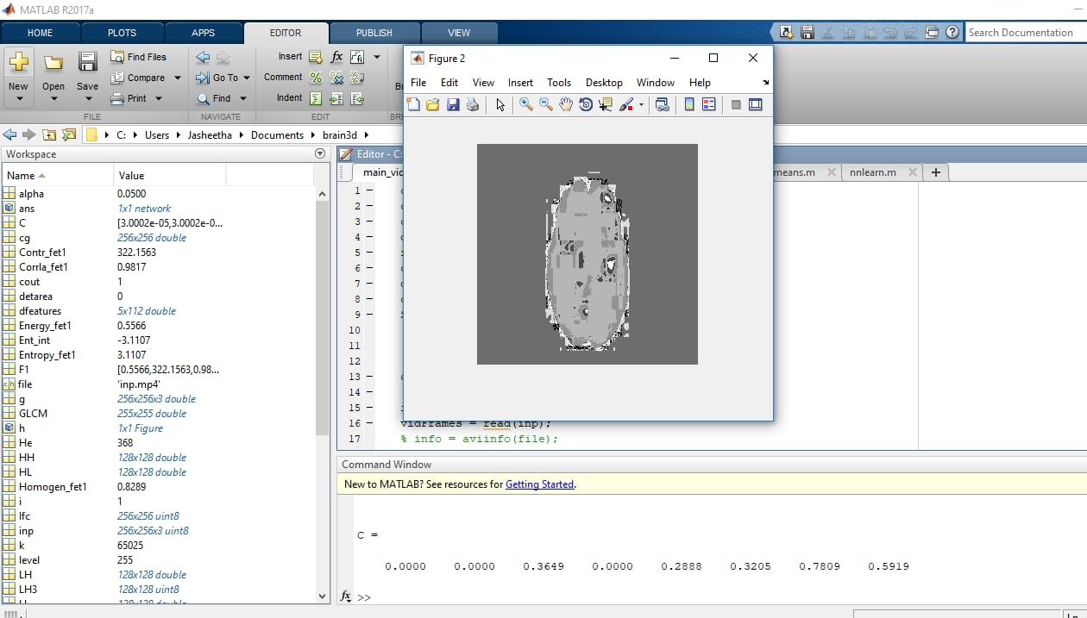

**Figure 4.6(a) Segmented Image.**

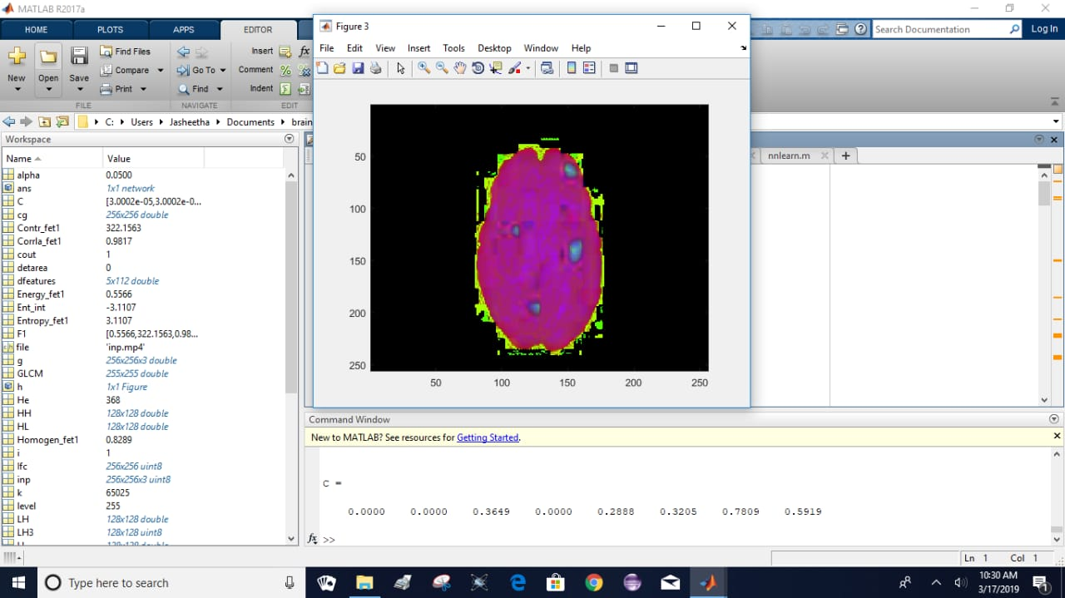

**Figure 4.6(b) Segmented Image**

**CONCLUSION**

This chapter shows the detailed description of working of the proposed model of Detection and Segmentation of Brain Tumour using Convolutional Neural Network and finally displaying an alert box to show the presence or absence of a tumour. If a tumour is present then the segmented image is displayed.

**CHAPTER 5**

**CONCLUSION**

**INTRODUCTION**

The proposed of detection and segmentation of brain tumour using Convolutional Neural Network is implemented. CNN is adopted for its fast training and accurate results. Input 3D MRI scans each having an approximate of 160 to 170 frames of MRI images are used to train the Convolutional Neural Network and test are run using different 3D MRI scan to examine the classifier accuracy.

**FUTURE SCOPE**

This application can be extended to make an automated classification of different diseases. Convolutional Neural Network being the latest methodology used it can find it application in determining the classification of several diseases in the future.

**CONCLUSION**

The proposed method of detection and segmentation of brain tumour was found out to be more accurate and better success rate compared to the previous models like SVM and ANN which are deemed as good methods but comparatively has takes less time to train. SVM model generates an accuracy of 80%-85%, while the proposed model shows an accuracy of 95%-97%. Convolutional Neural Networks can be similarly used in other medical applications that requires an automatic classifier.

**REFERENCES**

[1] Agrey Kato, RamadhanSinde, Ferlay J, Seorjamataram I, Ervik M, Dikshit R, Eser S, Mathers C, et al. Lyon, France: International Agency for Research on Cancer; 2013. [2014]. GLOBOCAN 2012 v1.0, Cancer Incidence and Mortality Worldwide: IARC CancerBase No.11.Available from: [http://globocan.iarc.fr](http://globocan.iarc.fr/) .

[2] Daniel wu Indian Council of Medical Research; 2013. [accessed on January 21, 2014]. National Cancer Registry Programed. Three Year Report of Population Based Cancer Registries: 2009-2011. Available from: [http://www.ncrpindia.org](http://www.ncrpindia.org/)

[3] World Health Organization. The Global Burden of Disease: 2004 Update. Geneva: World Health Organization; 2008.

[4] M.Ganesh, M.Naresh & C.Arvind,S “MRI Brain Image Segmentation using Enhanced Adaptive Fuzzy K-Means Algorithm”, Intelligent Automation & Soft Computing,vol.23,Issue 2,pp-325-330,2017.

[5] Nilesh Bhaskarrao Bahadure, Arun Kumar Ray, and Har Pal Thethi, “Image Analysis for MRI Based Brain Tumour Detection and Feature Extraction Using Biologically Inspired BWT and SVM”, International Journal of Biomedical Imaging, vol. 47, no. 10, pp3849–3852,2017

[6] Siddhi N.Nerurkar, “Brain Tumour Detection using Image Segmentation”, International Journal of Engineering Research in Computer Science and Engineering , Vol 4, Issue4,2017

[7] M.Alfonse and A.B. M. Salem, “An automatic classification of brain tumours through MRI using support vector machine,”Egyptian Computer Science Journal, vol. 40, pp. 11–21, 2016.

[8] Isa, N.A.M., & Salamah, S.A., “Adaptive fuzzy moving K-means clustering algorithm for image segmentation”. IEEE Transactions on Consumer Electronics. vol 55, Issue 4, pp. 15–25,2015

[9] Parveen and A. Singh, “Detection of brain tumour in MRI images, using combination of fuzzy c-means and SVM,” in Proceedings of the 2nd International Conference on Signal Processing and Integrated Networks (SPIN ’15), pp. 98–102, February 2015.

[10] Patel,K., & Jha.J “ Brain Tumour Image segmentation using adaptive clustering and level set method”, International Journal of Advanced Research in Computer and Technology, Vol 3,Issue 5,pp.1646-1650, 2014.

[11] Ardizzone.E, Pirrone.R, and Orazio.O.G, "Fuzzy C-MeansSegmentation on Brain MR Slices Corrupted by RF-Inhomogeneity," InProc. The 7th international workshop on Fuzzy Logic and Applications:Applications of Fuzzy Sets Theory, WILF '07, Springer- Verlag, pp:378-384, 2007.

[12] Bianrgi.P.M, Ashtiyani.M, and Asadi.S, "MRI Segmentation Using Fuzzy C-means Clustering Algorithm Basis Neural Network," InProc. ICTT A 3rdInternationai Conference on Information andCommunication Technologies: From Theory to Applications, pp: 1-5,2008.

[13] Sikka.K,Sinha.N, Singh P.K,” A fully automated algorithm modified FCM framework for improved brain MRI image segmentation’, Magnetic Resonance Imaging, vol.27, pp: 994--1004,2009..

[14] Xio.K, Ho.S.H and Bargiela.B, “Automatic Brain MRI Segmentation Scheme Based on Feature Weighting Factors Selection on Fuzzy C Means Clustering Algorithms with Gaussian Smoothing”, International Journal of Computational Intelligence in Bio informatics and Systems Biology (3):316-331,2009.

[15] S. Bauer et al., “A survey of mri-based medical image analysis for brain tumour studies,” Physics in medicine and biology, vol. 58, no. 13, pp. 97–129, 2013.

[16] D. N. Louis et al., “The 2007 who classification of tumours of the central nervous system,” Acta neuropathologica, vol. 114, no. 2, pp. 97–109,2007.

[17] E. G. Van Meir et al., “Exciting new advances in neuro-oncology: The avenue to a cure for malignant glioma,” CA: a cancer journal for clinicians, vol. 60, no. 3, pp. 166–193, 2010.

[18] G. Tabatabai et al., “Molecular diagnostics of gliomas: the clinical perspective,” Acta neuropathologica, vol. 120, no. 5, pp. 585–592, 2010.

[19] B. Menze et al., “The multimodal brain tumour image segmentation benchmark (brats),” IEEE Transactions on Medical Imaging, vol. 34, no. 10, pp. 1993–2024, 2015.

[20] Pereira, S., Pinto, A., Alves, V., et al.: ‘Brain tumour segmentation using convolutional neural networks in MRI images’, IEEE Trans. Med. Imaging, vol, 35, pp. 1240–1251,2016.

[21] Anitha.V., Murugavalli. S.: ‘Brain tumour classification using two-tier classifier with adaptive segmentation technique’, IET Comput. Vis., vol. 10, pp. 9–17, 2016.

[22] Nanthagopal, A.P., Sukanesh, R.: ‘Wavelet statistical texture features-based segmentation and classification of brain computed tomography images’, IET Image Process., vol. 7, pp. 25–32,2013.

[23] Sauwen, N., Acou, M., Van Cauter, S., et al.: ‘Comparison of unsupervised classification methods for brain tumour segmentation using multi-parametric MRI’, NeuroImage: Clin., vol. 12, pp. 753–764,2016.

[24] Ji, Z., Xia, Y., Sun, Q., et al.: ‘Fuzzy local Gaussian mixture model for brain MR image segmentation’, IEEE Trans. Inf. Technol. Biomed., vol. 16, pp. 339–347,2016.